Calgary Pro Plumbing Business Intelligence Dashboard
Business Intelligence & Data Analytics Project

Prepared By

Sukhpreet K. Sandhu
(Junior Data Analyst)

Client
Calgary Pro Plumbing

Industry
Residential & Commercial Plumbing Services

Project Type
Business Intelligence & Data Analytics

Software & Technologies

Microsoft Excel

MySQL Workbench

SQL

Microsoft Power BI

Power Query

Date:

June 2026 - July 2026

Project Note: This project was developed for Calgary Pro Plumbing as part of a real business analytics engagement. To protect business confidentiality, the dataset included in this portfolio has been simulated and anonymized. All analyses, SQL queries, dashboards, business processes, and recommendations reflect the original project workflow while using non-confidential data.

Table of Contents
Section |  | Page
Project Information |  |  | 1
Table of Contents |  |  | 2
Phase 1: Business Understanding |  |  | 3
1. Business Domain |  |  | 3
2. Business Context |  |  | 3
3. Business Problem Statement |  |  | 3
4. Business Objectives |  |  | 4
5. Stakeholder Identification |  |  | 5
6. Project Objective |  |  | 5
7. Project Scope |  |  | 5
8. Success Criteria |  |  | 6
Phase 2: Requirements Elicitation & Analysis |  |  | 6
1. Requirements Elicitation |  |  | 6
2. Business Requirements |  |  | 7
3. Functional Requirements |  |  | 7
4. Non-Functional Requirements |  |  | 7
5. Key Performance Indicators |  |  | 8
6. Assumptions |  |  | 8
7. Constraints |  |  | 8
8. Risks |  |  | 8
Phase 3: Data Discovery & Preparation |  |  | 9
1. Data Discovery |  |  | 9
2. Data Sources |  |  | 9
3. Dataset Overview |  |  | 9
4. Data Dictionary |  |  | 10-11
5. Entity Relationship Diagram |  |  | 11-12
6. Data Quality Assessment |  |  | 13
7. Data Cleaning |  |  | 13
8. Data Transformation |  |  | 13
9. Data Validation |  |  | 14
Phase 4: SQL Analysis |  |  | 14
1. SQL Analysis |  |  | 14
2. Database Schema |  |  | 14-15
3. Business Questions |  |  | 15
4. SQL Queries |  |  | 15-24
5. SQL Analysis Summary |  |  | 24
Phase 5: Power BI Dashboard Development |  |  | 24
1. Dashboard Objective |  |  | 24
2. Data Import and Modeling |  |  | 24
3. Dashboard Pages |  |  | 25
4. Dashboard Design Components |  |  | 25-26
5. KPI Definitions |  |  | 26
6. Dashboard Design |  |  | 26
7. Dashboard Interactivity |  |  | 26
8. Dashboard Screenshots |  |  | 26-28
Phase 6: Business Insights & Recommendations |  |  | 29
1. Business Insights |  |  | 29
2. Key Findings |  |  | 29
3. Business Recommendations |  |  | 30
4. Business Value |  |  | 30
Phase 7: Project Conclusion |  |  | 31
1. Project Summary |  |  | 31
2. Project Objectives Achieved |  |  | 31
3. Skills Demonstrated |  |  | 31-32
4. Project Challenges |  |  | 32
5. Project Limitations |  |  | 32
6. Future Improvements |  |  | 33
7. Conclusion |  |  | 33

Phase 1: Business Understanding

Project Information
Project Name: Calgary Pro Plumbing Business Intelligence Dashboard
Client: Calgary Pro Plumbing
Industry: Residential & Commercial Plumbing Services
Project Type: Business Intelligence & Data Analytics
Prepared By: Sukhpreet Kaur Sandhu
Role: Junior Data Analyst
Date: June 2026

1. Business Domain

Calgary Pro Plumbing operates within the Residential and Commercial Plumbing Services industry. The company provides plumbing installation, maintenance, repair, and emergency services to residential homeowners and commercial clients throughout Calgary and surrounding communities.

2. Business Context

Calgary Pro Plumbing is a growing service-based company that has expanded its customer base over the past several years. Operational data, including customer records, technician assignments, invoices, appointments, and completed jobs, is currently maintained across multiple Microsoft Excel spreadsheets.

Although the company collects significant amounts of operational data, the information is primarily used for record keeping rather than business analysis. Reporting is currently performed through manual consolidation of multiple Excel spreadsheets, making it difficult for management to monitor performance, identify trends, and make timely business decisions. The company recognizes the need for a centralized reporting solution that provides greater visibility into business performance and supports future growth.

3. Business Problem Statement

Calgary Pro Plumbing currently lacks a centralized reporting solution that provides visibility into operational and financial performance. Business decisions are largely based on manual reporting and intuition, limiting the organization's ability to monitor key performance indicators, identify operational trends, evaluate technician performance, and support strategic decision-making through data-driven insights.

4. Business Objectives

The primary business objectives for Calgary Pro Plumbing are:
- Increase annual revenue
- Improve operational efficiency
- Support data-driven decision-making
- Improve customer retention
- Increase technician productivity
- Improve customer satisfaction
- Identify the most profitable plumbing services
- Understand seasonal demand patterns
- Support future business growth

5. Stakeholder Identification

Stakeholder | Role | Interest
Business Owner | Executive Sponsor | Monitor revenue, profitability, and business performance
Office Administrator | Operations | Track scheduling, invoices, and daily operations
Plumbing Technicians | Operational Users | Monitor workload and service performance
Customers | Service Recipients | Receive improved service quality through operational improvements
Junior Data Analyst | Project Analyst | Analyze business data and deliver actionable insights

6. Project Objective

Design and develop an interactive Business Intelligence dashboard that transforms operational data into actionable insights, enabling Calgary Pro Plumbing to monitor key performance indicators (KPIs), improve operational visibility, and support data-driven decision-making.

7. Project Scope

Scope In

This project includes:

Revenue analysis

Customer analysis

Technician performance analysis

Service demand analysis

Geographic performance analysis

Interactive Power BI dashboard

KPI reporting

Business recommendations

Scope Out

This project excludes:
- Payroll Management
- Inventory Management
- Accounting System Implementation
- Website Development
- Mobile Application Development
- Marketing Campaign Execution

8. Success Criteria

The project will be considered successful if it:
- Delivers an interactive Business Intelligence dashboard.
- Provides centralized reporting of key business metrics.
- Enables management to monitor operational performance through KPIs.
- Identifies high-performing services and technicians.
- Supports informed, data-driven decision-making.
- Reduces manual reporting effort.
- Provides actionable insights that support future business growth.

Phase 1 Summary: Phase 1 established a clear understanding of Calgary Pro Plumbing's business operations, challenges, objectives, project scope, and stakeholder requirements. This understanding provides the foundation for the remaining phases of the Business Intelligence project.

Phase 2: Requirements Elicitation & Analysis

1. Requirements Elicitation

For this project, requirements were identified based on discussions with the client regarding current business challenges, operational processes, reporting limitations, and desired business outcomes.

2. Business Requirements

ID | Business Requirement
BR-001 | Provide centralized visibility into operational and financial performance.
BR-002 | Monitor monthly and annual revenue trends.
BR-003 | Measure technician productivity and performance.
BR-004 | Identify the most profitable plumbing services.
BR-005 | Track customer satisfaction and repeat customer behaviour.
BR-006 | Analyze seasonal demand for plumbing services.
BR-007 | Report service activity across Calgary communities.
BR-008 | Reduce manual reporting through automated dashboards and reporting.

3. Functional Requirements

ID | Functional Requirement
FR-001 | Display total revenue.
FR-002 | Display total completed jobs.
FR-003 | Display average invoice value.
FR-004 | Display average customer satisfaction rating.
FR-005 | Display technician performance metrics.
FR-006 | Display revenue by plumbing service.
FR-007 | Display monthly revenue trends.
FR-008 | Display service demand by geographic area.
FR-009 | Allow dashboard filtering by date, technician, service type, and location.

4. Non-Functional Requirements
- The dashboard shall be user-friendly and easy to navigate.
- Dashboard visualizations shall load efficiently.
- Reports shall present accurate and validated data.
- Dashboard design shall maintain a consistent visual style.
- Reports shall support business decision-making through clear visualizations.
- Data shall be organized for future scalability.

5. Key Performance Indicators (KPIs)
- Total Revenue
- Total Jobs Completed
- Average Invoice Value
- Average Customer Rating
- Number of Emergency Jobs
- Revenue by Service
- Revenue by Month
- Revenue by Service Area
- Technician Productivity

6. Assumptions
- Operational data is available within company spreadsheets.
- Data accurately represents completed plumbing jobs.
- Management is willing to adopt dashboard reporting.
- Business records are complete and suitable for analysis.
- Stakeholder requirements remain stable throughout the project.

7. Constraints
- Project is completed by a single Junior Data Analyst.
- Dashboard development will utilize Microsoft Power BI.
- Project timeline is limited.
- Budget is assumed to be unavailable for additional software.
- Access to confidential business information is limited.

8. Risks

Risk | Mitigation Strategy
Dashboard requirements may change. | Validate requirements before development begins.
Data quality issues. | Perform data cleaning and validation during data preparation.
Scope expansion. | Adhere to the approved project scope.
Incomplete or missing business records | Review the dataset for missing or incomplete information and validate records before analysis.
Changing reporting requirements | Maintain regular communication with stakeholders and update dashboard requirements as business needs evolve.

Phase 2 Summary: During this phase, business and stakeholder requirements were identified, analyzed, and documented to define the objectives and expected functionality of the Business Intelligence solution. Business, functional, and non-functional requirements, along with key performance indicators, assumptions, constraints, and project risks, established a clear foundation for data preparation, analysis, and dashboard development.

Phase 3: Data Discovery & Preparation

1. Data Discovery

For this project, operational data representing the day-to-day activities of Calgary Pro Plumbing was prepared for analysis. The dataset includes customer information, technician assignments, completed service jobs, invoices, service types, appointment dates, service locations, and customer satisfaction ratings. The data was reviewed for completeness, consistency, and suitability before being used for analysis.

2. Data Sources

Data Source | Description
Customer Records | Customer information, contact details, and service history
Job Records | Completed plumbing service records
Technician Records | Technician information and job assignments
Service Catalogue | Plumbing service categories and pricing
Invoice Records | Revenue generated from completed services
Customer Feedback Records | Customer satisfaction ratings collected after service

3. Dataset Overview

The Calgary Pro Plumbing dataset consists of multiple related tables that capture different aspects of the company's daily operations. The data is organized into separate datasets to support efficient analysis, establish relationships between business entities, and enable interactive reporting within Power BI.

Dataset | Purpose | Records
Customers | Stores customer information and contact details | 180
Jobs | Stores completed plumbing service records | 520
Technicians | Stores technician information and job assignments | 8
Services | Stores plumbing service categories | 12
Invoices | Stores invoice details and revenue information | 520
Customer Feedback | Stores customer satisfaction ratings | 432

4. Data Dictionary

Customer Table
Field | Data Type | Description
CustomerID | Integer | Unique customer identifier
CustomerName | Text | Customer full name
Phone | Text | Customer phone number
Email | Text | Customer email address
Community | Text | Calgary community
PostalCode | Text | Customer postal code

Jobs Table
Field | Data Type | Description
JobID | Integer | Unique job identifier
CustomerID | Integer | References the customer
TechnicianID | Integer | Assigned technician
ServiceID | Integer | Plumbing service performed
JobDate | Date | Date the job was completed
InvoiceID | Integer | Related invoice
JobStatus | Text | Completed, Cancelled or Rescheduled
EmergencyCall | Yes/No | Indicates emergency service
LabourHours | Decimal | Hours spent completing the job

Technician Table
Field | Data Type | Description
TechnicianID | Integer | Unique technician identifier
TechnicianName | Text | Technician full name
ExperienceYears | Integer | Years of plumbing experience
Certification | Text | Professional certification

Services Table
Field | Data Type | Description
ServiceID | Integer | Unique service identifier
ServiceName | Text | Plumbing service provided
Category | Text | Service category
StandardPrice | Currency | Standard service price

Invoice Table
Field | Data Type | Description
InvoiceID | Integer | Unique invoice identifier
JobID | Integer | Associated plumbing job
InvoiceAmount | Currency | Total invoice amount
PaymentMethod | Text | Payment method used
PaymentStatus | Text | Paid or Outstanding

Customer Feedback Table
Field | Data Type | Description
FeedbackID | Integer | Unique feedback identifier
JobID | Integer | Associated plumbing job
Rating | Decimal | Customer satisfaction rating (1–5)
Comments | Text | Customer feedback comments

5. Entity Relationship Diagram

Entity Relationship Model: The Calgary Pro Plumbing data model consists of six related datasets connected through primary and foreign keys. The Customers, Technicians, Services, Invoices, and Customer Feedback tables connect to the Jobs table, which acts as the central operational table. These relationships enable accurate reporting, aggregation, and filtering within Power BI.

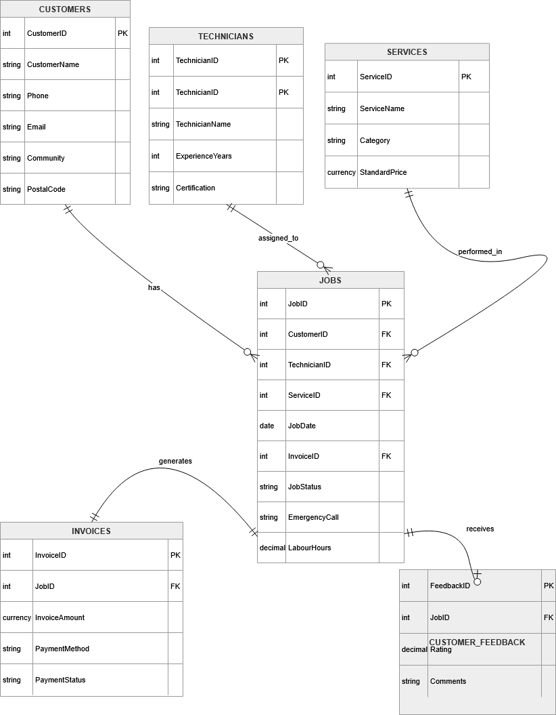
Figure 1: Entity Relationship Diagram (ERD) showing the relationships between the Customers, Jobs, Technicians, Services, Invoices, and Customer Feedback tables.

6. Data Quality Assessment

The project data was reviewed to identify potential quality issues before analysis. Validation checks were performed to improve data consistency and ensure the information was suitable for Business Intelligence reporting.

Quality Check | Result
Missing Values | Reviewed and addressed where necessary
Duplicate Records | No duplicate records identified
Invalid Dates | Date formats validated and standardized
Negative Invoice Values | No negative invoice amounts identified
Inconsistent Service Names | Service names standardized across the dataset
Customer Ratings | Verified to be within the valid range (1–5)

Overall, the data was determined to be suitable for reporting and dashboard development.

7. Data Cleaning

The following data preparation activities were completed before analysis:
- Removed duplicate records.
- Standardized service names.
- Standardized date formats.
- Corrected inconsistent text formatting.
- Reviewed missing values.
- Validated invoice amounts.
- Verified customer satisfaction ratings.
- Removed unnecessary fields.

8. Data Transformation

The dataset was transformed to support reporting and visualization in Power BI. The following transformations were applied:
- Created Year and Month fields from the job date.
- Categorized plumbing services into service groups.
- Standardized Calgary community names.
- Established relationships between related datasets.
- Created calculated fields required for reporting.
- Structured the data model for efficient dashboard development.
- Converted text-based invoice amounts into numeric values to support SQL calculations and reporting.

9. Data Validation

Following data preparation, validation checks were completed to verify the accuracy and consistency of the final dataset. Validation activities included:
- Confirming invoice totals.
- Verifying customer and technician relationships.
- Reviewing service classifications.
- Checking date consistency.
- Validating customer satisfaction ratings.
- Confirming successful table relationships within the data model.
The dataset successfully passed validation and was approved for dashboard development.

Phase 3 Summary: During this phase, operational data was organized, reviewed, and prepared for analysis. Data quality checks, cleaning activities, transformations, and validation ensured the dataset was accurate, consistent, and suitable for Business Intelligence reporting. A structured data model was established to support SQL analysis and Power BI dashboard development.

Phase 4: SQL Analysis

1. SQL Analysis

SQL was used to analyze Calgary Pro Plumbing's operational data and answer key business questions identified during the requirements analysis phase. The analysis focused on revenue, customer activity, technician performance, service demand, and customer satisfaction. The results were later used to support dashboard development in Power BI and provide business recommendations.

2. Database Schema
Table | Description
Customers | Customer information and contact details
Jobs | Completed plumbing service records
Technicians | Technician information
Services | Plumbing services offered
Invoices | Invoice and payment information
Customer Feedback | Customer satisfaction ratings

3. Business Questions
ID | Business Question
BQ-001 | What is the total revenue generated?
BQ-002 | How many plumbing jobs were completed?
BQ-003 | Which plumbing services generate the highest revenue?
BQ-004 | Which technicians completed the most jobs?
BQ-005 | What is the average invoice amount?
BQ-006 | How does revenue change by month?
BQ-007 | Which Calgary communities generate the highest revenue?
BQ-008 | What is the average customer satisfaction rating?
BQ-009 | What percentage of jobs are emergency service calls?
BQ-010 | Which payment method is used most frequently?

4. SQL Queries

Query 1:

Business Question: What is the total revenue generated by Calgary Pro Plumbing?

SQL Query:
SELECT
ROUND(SUM(
CAST(REPLACE(REPLACE(InvoiceAmount, '$', ''), ',', '') AS DECIMAL(10,2))
), 2) AS TotalRevenue
FROM invoices;

Result:
Total Revenue: $324,895.00
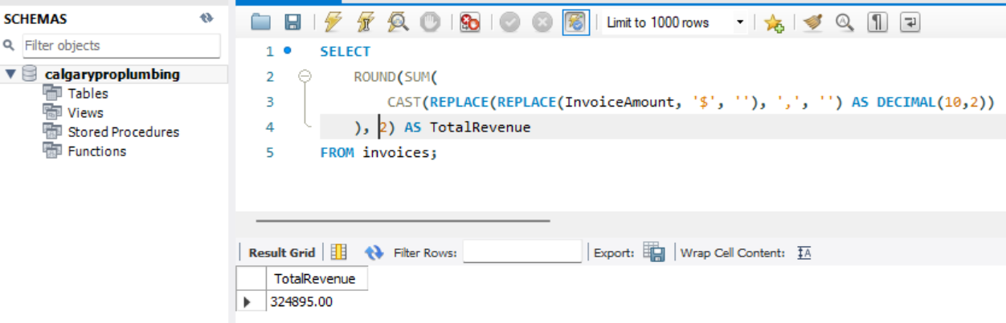
Figure 2: SQL Query Result - Total Revenue Generated by Calgary Pro Plumbing

Analysis: The SQL query calculated a total revenue of $324,895.00 from all recorded invoices. This represents the total income generated from completed plumbing services during the reporting period. Revenue is one of the organization's primary Key Performance Indicators (KPIs) and provides management with an overall measure of business performance. This value serves as a benchmark for monitoring financial performance, evaluating business growth, and supporting future operational and strategic planning.

Query 2:

Business Question: How many plumbing jobs have been completed?

SQL Query:
SELECT
COUNT(*) AS TotalCompletedJobs
FROM jobs
WHERE JobStatus = 'Completed';

Result:
Total Completed Jobs: 478
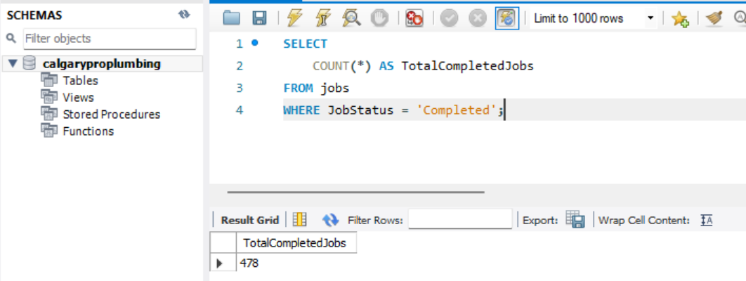
Figure 3: SQL Query Result - Total Completed Plumbing Jobs

Analysis: The SQL query counted the total number of completed plumbing jobs recorded in the dataset. This metric measures the company's operational productivity and indicates the volume of successfully completed service requests. Monitoring completed jobs helps management evaluate business performance, workforce utilization, and overall service delivery. The remaining records represent cancelled or rescheduled jobs.

Query 3:

Business Question: What is the average invoice amount?

SQL Query:
SELECT
ROUND(
AVG(
CAST(REPLACE(REPLACE(InvoiceAmount, '$', ''), ',', '') AS DECIMAL(10,2))
),
2
) AS AverageInvoiceValue
FROM invoices;
Result:
Average Invoice Value: 624.80
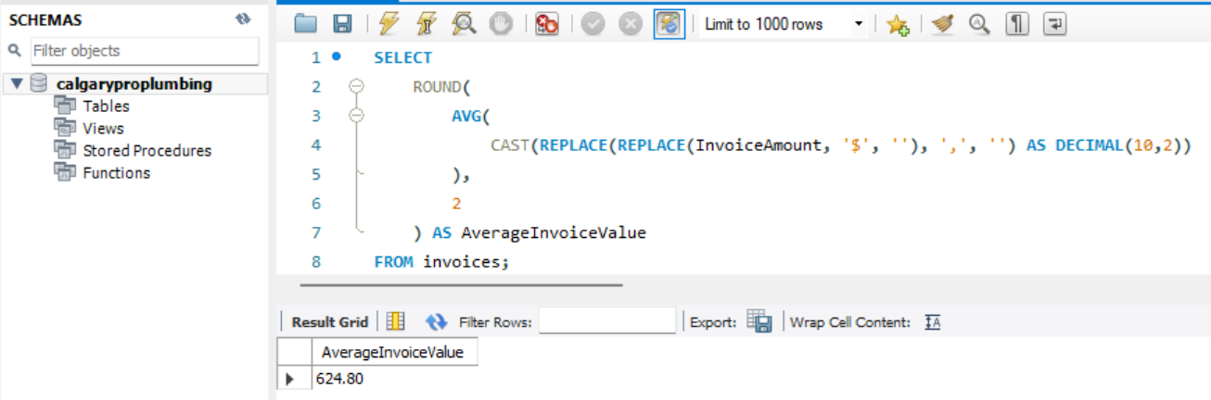
Figure 4: SQL Query Result - Average Invoice Value

Analysis: The SQL query calculated the average value of all invoices issued by Calgary Pro Plumbing. This KPI provides insight into the average revenue generated per completed job and helps management understand customer spending patterns. Tracking the average invoice value supports pricing decisions, financial forecasting, and revenue analysis.

Query 4:

Business Question: Which plumbing services generate the highest revenue?

SQL Query:
SELECT
s.ServiceName,
ROUND(
SUM(
CAST(REPLACE(REPLACE(i.InvoiceAmount, '$', ''), ',', '') AS DECIMAL(10,2))
),
2
) AS TotalRevenue
FROM jobs j
JOIN services s
ON j.ServiceID = s.ServiceID
JOIN invoices i
ON j.InvoiceID = i.InvoiceID
GROUP BY s.ServiceName
ORDER BY TotalRevenue DESC;

Result:
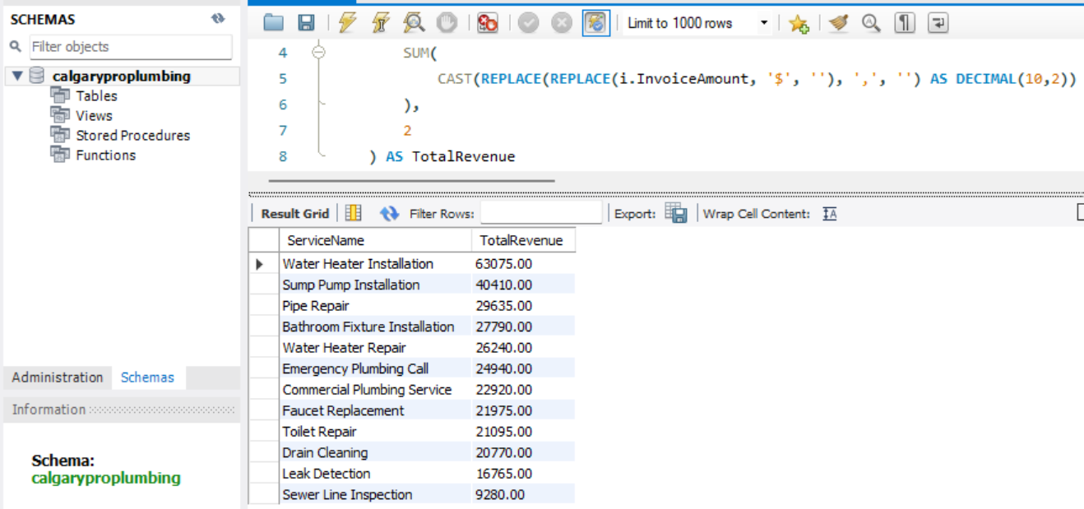
Figure 5: SQL Query Result - Revenue Generated by Plumbing Service

Analysis: The SQL query summarized total revenue by plumbing service and ranked the services from highest to lowest revenue. This analysis identifies the company's most profitable services and helps management understand customer demand. These insights can support service pricing, marketing initiatives, and resource allocation.

Query 5:

Business Question: Which technicians completed the highest number of plumbing jobs?

SQL Query:
SELECT
t.TechnicianName,
COUNT(j.JobID) AS JobsCompleted
FROM jobs j
JOIN technicians t
ON j.TechnicianID = t.TechnicianID
GROUP BY t.TechnicianName
ORDER BY JobsCompleted DESC;

Result:
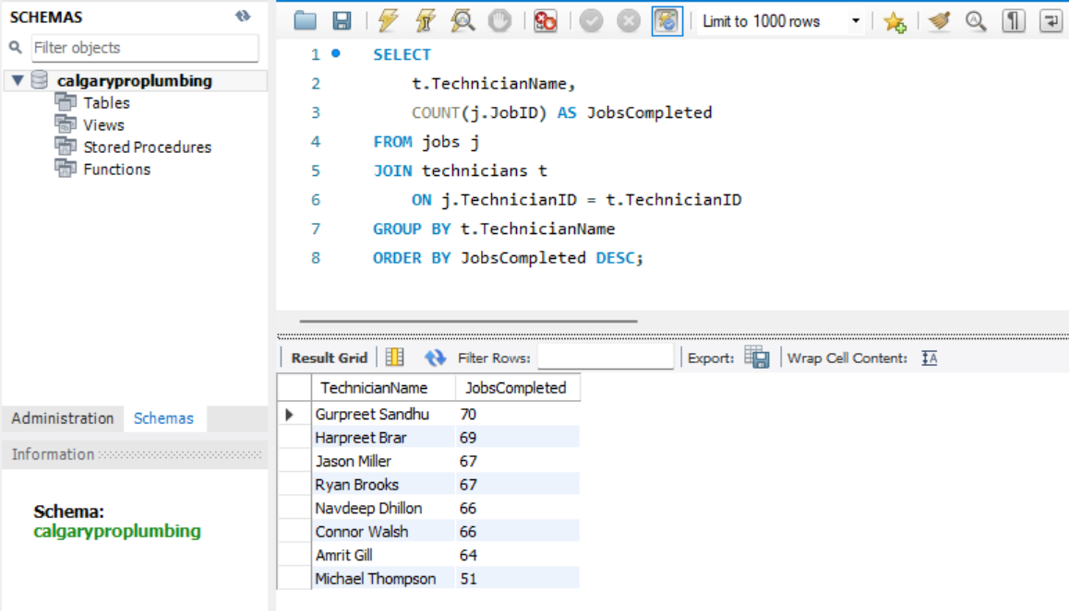
Figure 6: SQL Query Result - Jobs Completed by Technician

Analysis: The SQL query counted the number of completed jobs assigned to each technician. The results highlight technician productivity and workload distribution across the organization. This information supports performance evaluation, workforce planning, and scheduling decisions.

Query 6:

Business Question: How does revenue vary by month?

SQL Query:
SELECT
MONTH(STR_TO_DATE(JobDate, '%Y-%m-%d')) AS Month,
ROUND(
SUM(
CAST(REPLACE(REPLACE(i.InvoiceAmount, '$', ''), ',', '') AS DECIMAL(10,2))
),
2
) AS MonthlyRevenue
FROM jobs j
JOIN invoices i
ON j.InvoiceID = i.InvoiceID
GROUP BY MONTH(STR_TO_DATE(JobDate, '%Y-%m-%d'))
ORDER BY Month;

Result:
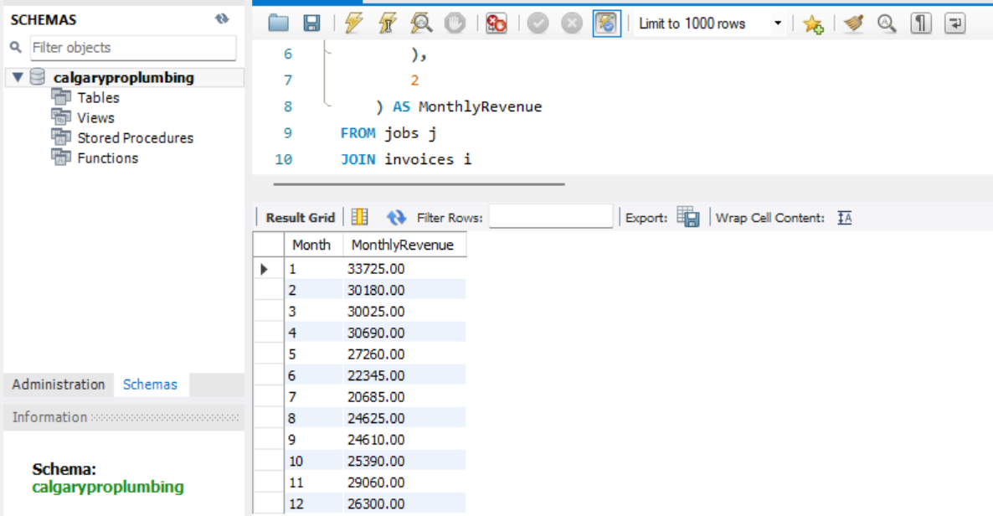
Figure 7: SQL Query Result – Monthly Revenue Analysis

Analysis: The SQL query calculated monthly revenue to identify revenue trends over time. Analyzing revenue by month enables management to recognize seasonal patterns, forecast future demand, and support financial planning.

Query 7:

Business Question: Which Calgary communities generate the highest revenue?

SQL Query:
SELECT
c.Community,
ROUND(
SUM(
CAST(REPLACE(REPLACE(i.InvoiceAmount, '$', ''), ',', '') AS DECIMAL(10,2))
),
2
) AS CommunityRevenue
FROM jobs j
JOIN customers c
ON j.CustomerID = c.CustomerID
JOIN invoices i
ON j.InvoiceID = i.InvoiceID
GROUP BY c.Community
ORDER BY CommunityRevenue DESC;

Result:
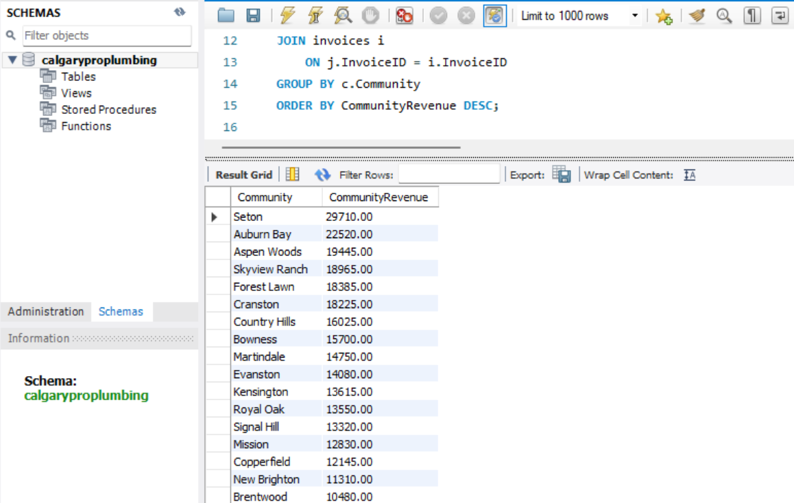
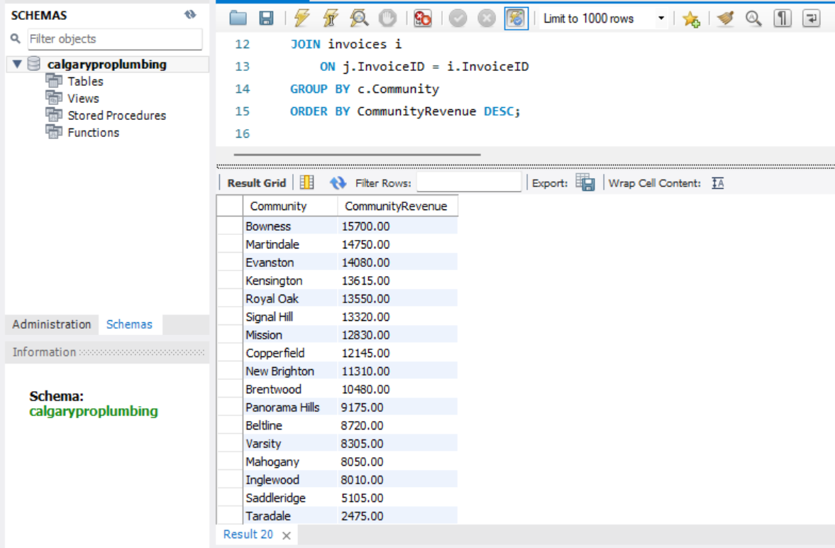
Figure 8: SQL Query Result - Revenue by Calgary Community

Analysis: The SQL query calculated revenue generated from each Calgary community. This analysis identifies the company's strongest service areas and helps management understand geographic demand for plumbing services. The results support strategic planning, marketing efforts, and service expansion decisions.

Query 8:

Business Question: What is the average customer satisfaction rating?
SQL Query:
SELECT
ROUND(AVG(Rating), 2) AS AverageCustomerRating
FROM customerfeedback;

Result:

Average Customer Rating: 4.39
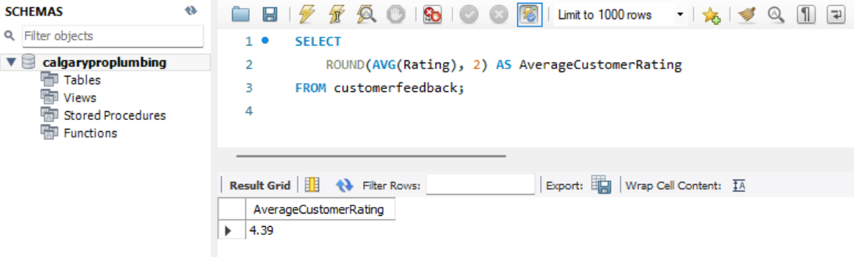
Figure 9: SQL Query Result - Average Customer Satisfaction Rating

Analysis: The SQL query calculated the average customer satisfaction rating based on customer feedback records. Customer satisfaction is an important service quality indicator and helps management monitor customer experience, identify improvement opportunities, and maintain high service standards.

Query 9:

Business Question: How many emergency plumbing calls were completed?

SQL Query:
SELECT
COUNT(*) AS EmergencyJobs
FROM jobs
WHERE EmergencyCall = 'Yes';

Result:
Emergency Jobs: 97

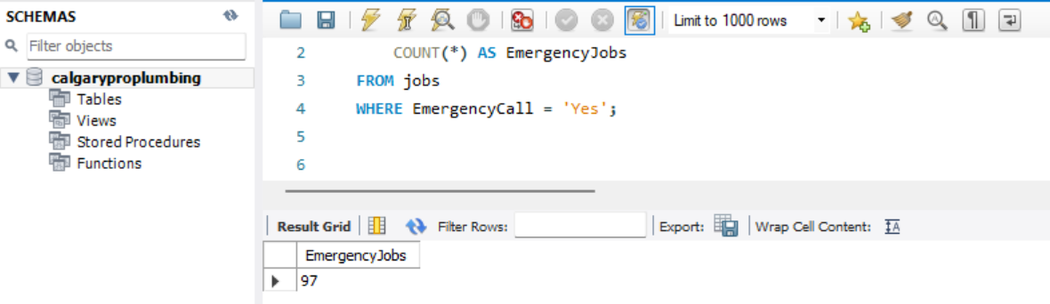
Figure 10: SQL Query Result - Emergency Plumbing Service Calls

Analysis: The SQL query counted the number of emergency plumbing service calls completed during the reporting period. This metric helps management understand the demand for emergency services and supports staffing, scheduling, and operational planning.

Query 10:

Business Question: Which payment method is used most frequently?

SQL Query:
SELECT
PaymentMethod,
COUNT(*) AS NumberOfTransactions
FROM invoices
GROUP BY PaymentMethod
ORDER BY NumberOfTransactions DESC;

Result:
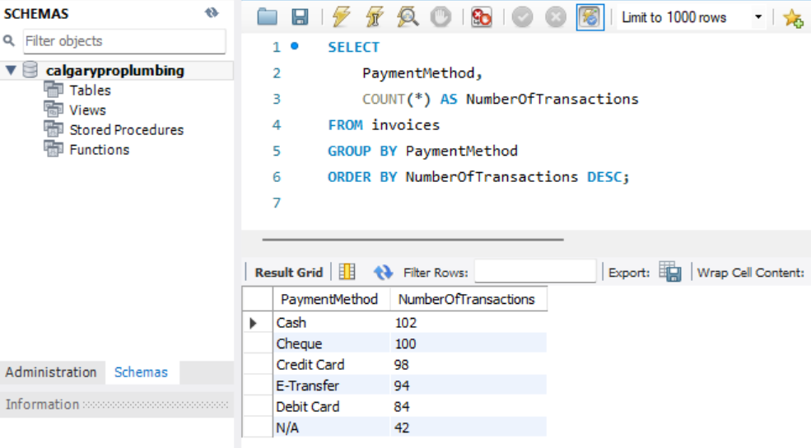
Figure 11: SQL Query Result - Payment Method Distribution

Analysis: The SQL query summarized customer payment methods and ranked them by frequency of use. Understanding payment preferences helps the business optimize payment processing, improve customer convenience, and support financial operations.

5. SQL Analysis Summary

SQL analysis was used to answer key business questions related to revenue, completed jobs, average invoice value, service performance, technician productivity, monthly trends, geographic performance, customer satisfaction, emergency service demand, and payment methods. The results provided a clear analytical foundation for dashboard development and helped identify the main metrics Calgary Pro Plumbing should monitor through Power BI.

Phase 4 Summary: During this phase, SQL queries were developed and executed to analyze Calgary Pro Plumbing's operational and financial data. The analysis transformed raw business records into meaningful insights by summarizing key performance indicators, identifying revenue trends, evaluating service and technician performance, and reviewing customer satisfaction. These SQL results will support the development of the Power BI dashboard and the final business recommendations.

Phase 5: Power BI Dashboard Development

1. Dashboard Objective: The objective of the Power BI dashboard was to develop an interactive Business Intelligence solution for Calgary Pro Plumbing that enables management to monitor operational and financial performance through visual analytics. The dashboard combines data from multiple related datasets into a single reporting interface, allowing users to analyze revenue, technician performance, service demand, customer satisfaction, payment methods, and business trends to support data-driven decision-making.

2. Data Import and Modeling: The cleaned datasets prepared during the data preparation phase were imported into Power BI. Relationships were established between the Customers, Jobs, Technicians, Services, Invoices, and Customer Feedback tables to create a structured relational data model. This model enabled accurate aggregation, filtering, and reporting across all dashboard visualizations.

This figure below illustrates the Power BI data model and relationships established between the project datasets.
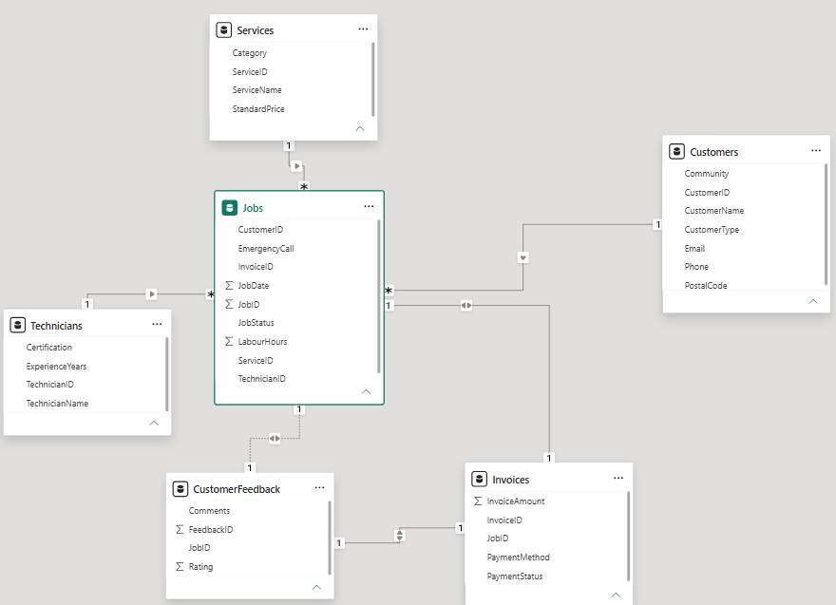
Figure 12: Power BI Relationship Model showing the relationships between the Customers, Jobs, Services, Technicians, Invoices, and Customer Feedback tables.
3. Dashboard Pages: The Power BI solution consists of two interactive dashboard pages designed for different reporting needs.

Dashboard 1 (Executive Overview): The Executive Overview dashboard provides management with a high-level summary of business performance through key performance indicators and business trend visualizations.

Key Performance Indicators (KPIs)
- Total Revenue
- Total Jobs
- Average Invoice
- Average Customer Rating
- Emergency Jobs

Visualizations
- Monthly Revenue (Line Chart)
- Revenue by Service (Clustered Bar Chart)
- Jobs Completed by Technician (Clustered Column Chart)

Dashboard 2 (Operational Performance): The Operational Performance dashboard provides detailed operational insights to support day-to-day business monitoring.

Visualizations
- Payment Method Distribution (Donut Chart)
- Customer Rating Distribution (Clustered Column Chart)
- Revenue by Community (Clustered Bar Chart)

Interactive Filters (Slicers)
- Service
- Technician
- Job Date

The slicers allow users to dynamically filter the dashboard, making it easier to analyze technician workload and payment trends based on specific services, technicians, or reporting periods.

4. Dashboard Design Components
Component | Purpose
KPI Cards | Display key business metrics at a glance.
Line Chart | Visualize monthly revenue trends.
Clustered Bar Chart | Compare revenue across services and communities.
Clustered Column Chart | Compare technician performance and customer ratings.
Donut Chart | Display payment method distribution.
Slicers | Allow users to interactively filter dashboard results.

5. KPI Definitions
KPI | Definition
Total Revenue | Total revenue generated from completed plumbing services.
Total Jobs | Total number of completed plumbing jobs.
Average Invoice | Average invoice amount per completed service.
Average Customer Rating | Average customer satisfaction rating received from customers.
Emergency Jobs | Total number of emergency plumbing service calls.

6. Dashboard Design: The dashboards were designed using a professional blue and white colour scheme to provide a clean and consistent user experience. KPI cards were positioned at the top of the Executive Overview dashboard to highlight key business metrics, while charts were arranged to present revenue trends and operational comparisons in a logical and easy-to-read layout. Interactive slicers were included on the Operational Performance dashboard to allow users to filter and analyze the data from different.

7. Dashboard Interactivity: The Power BI dashboards include interactive filtering and cross-highlighting capabilities. Selecting values within slicers automatically updates the related charts and KPI cards, allowing users to analyze business performance by service, technician, and reporting period. This functionality improves data exploration and supports informed business decisions.

8. Dashboard Screenshots

Power Query Editor:
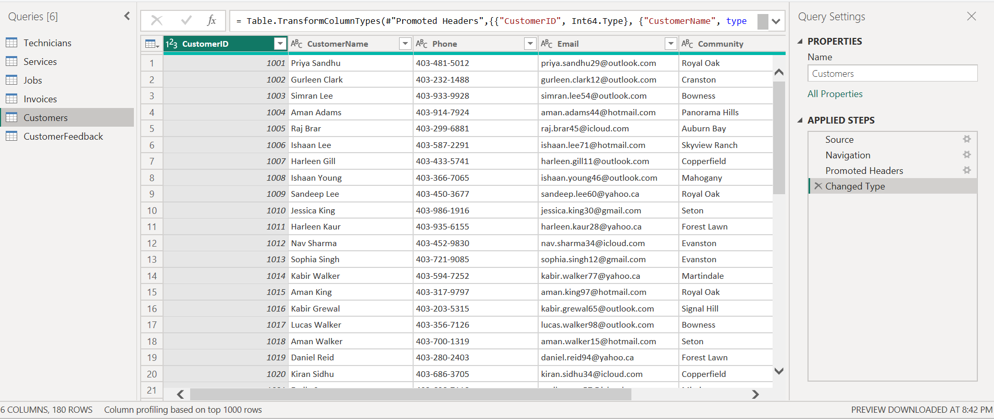
Figure 13: Power Query Editor showing the customer dataset after data import, header promotion, and data type transformation.

Data Type Transformation:
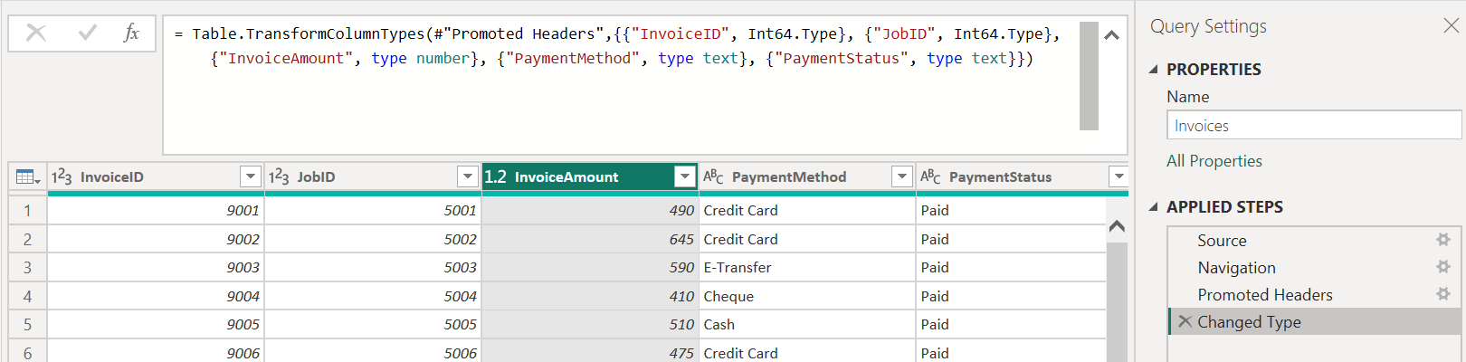
Figure 14: Power Query Editor showing data type transformation applied to the invoices dataset to ensure accurate numerical calculations and reporting in Power BI.

Executive Overview Dashboard:
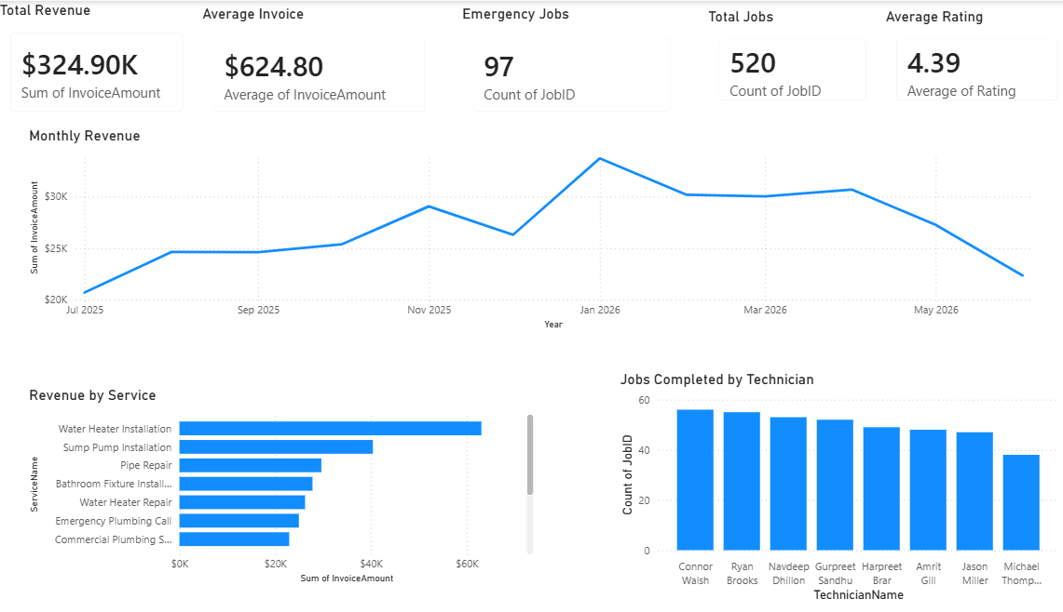
Figure 15: Executive Overview dashboard displaying key performance indicators (KPIs), monthly revenue trends, revenue by service, and technician performance.

Operational Performance Dashboard:
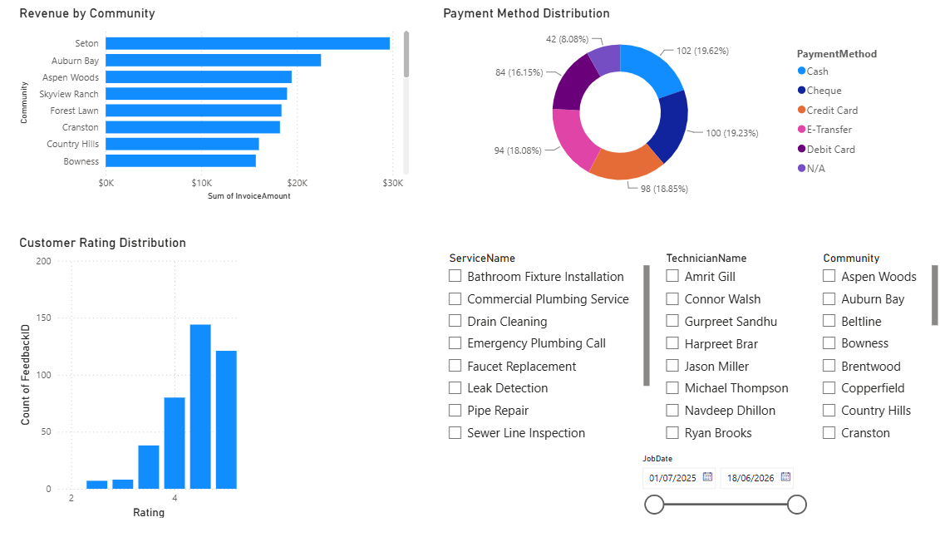
Figure 16: Operational Performance dashboard displaying revenue by community, payment method distribution, customer rating distribution, and interactive slicers for service, technician, community, and job date filtering.

Phase 5 Summary: During this phase, Power BI was used to develop two interactive Business Intelligence dashboards that present Calgary Pro Plumbing's operational and financial performance. The Executive Overview dashboard provides management with a high-level summary of key business metrics, while the Operational Performance dashboard offers detailed insights into technician productivity, customer satisfaction, service demand, and payment methods. Together, the dashboards provide management with an interactive reporting solution that supports performance monitoring, trend analysis, and data-driven decision-making.

Phase 6: Business Insights and Recommendations

1. Business Insights: The SQL analysis and Power BI dashboard provided several valuable insights into Calgary Pro Plumbing's operational and financial performance. These findings help management understand current business performance, identify trends, and support future planning.

2. Key Findings

2.1 Revenue Performance: The business generated a total revenue of $324,895.00 during the reporting period. Monthly revenue analysis showed fluctuations throughout the year, with revenue increasing steadily during several months before reaching its highest level in January 2026. Revenue decreased slightly toward the end of the reporting period, indicating an opportunity to investigate seasonal demand and business activity.

2.2 Job Performance: A total of 520 plumbing jobs were completed during the reporting period. This demonstrates a consistent workload and provides management with an overview of service demand across the business.

2.3 Emergency Services: The company completed 97 emergency plumbing jobs, representing an important portion of its overall workload. Monitoring emergency service demand can assist management in scheduling technicians and ensuring resources are available when urgent service requests occur. Emergency jobs represented approximately one fifth of all service requests.

2.4 Customer Satisfaction: The average customer satisfaction rating was 4.39 out of 5, indicating that customers were generally satisfied with the quality of services provided. Maintaining high customer satisfaction is important for customer retention and future business growth.

2.5 Invoice Analysis: The average invoice value was $624.80, providing insight into the average revenue generated from each completed plumbing service. This metric can be used to monitor pricing strategies and evaluate business profitability over time.

2.6 Service Performance: Revenue varied across different plumbing services. Some services generated significantly higher revenue than others, helping management identify the most profitable services and areas where additional marketing or operational improvements may be beneficial.

2.7 Technician Performance: The technician performance analysis showed differences in the number of completed jobs among technicians. This information can assist management in evaluating workload distribution, resource allocation, and future staffing requirements.

2.8 Payment Methods: The dashboard showed the distribution of customer payment methods. Understanding customer payment preferences helps the business improve payment processes and deliver a better customer experience.

3. Business Recommendations

Based on the analysis, the following recommendations are proposed:

Recommendation 1: Continue monitoring monthly revenue trends to identify seasonal fluctuations and develop strategies to maintain consistent revenue throughout the year.

Recommendation 2: Promote high-performing plumbing services through targeted marketing campaigns to increase revenue and business growth.

Recommendation 3: Monitor technician workloads regularly to ensure work is distributed fairly and resources are used efficiently.

Recommendation 4: Continue maintaining high customer satisfaction by monitoring customer feedback and responding promptly to service concerns.

Recommendation 5: Review emergency service demand regularly to ensure sufficient technician availability during periods of increased emergency requests.

Recommendation 6: Analyze customer payment preferences periodically to improve payment options and enhance the customer experience.

4. Business Value

This Business Intelligence solution provides Calgary Pro Plumbing with an interactive reporting platform that transforms operational data into meaningful business insights. Management can monitor key performance indicators, identify trends, evaluate operational performance, and make informed decisions using real-time dashboard visualizations.

Phase 6 Summary: During this phase, SQL analysis and Power BI reporting were used to identify key operational and financial insights for Calgary Pro Plumbing. The findings highlighted revenue performance, customer satisfaction, technician productivity, service demand, and payment trends. Based on these insights, practical business recommendations were developed to support improved operational efficiency, customer service, and future business growth.

Phase 7: Project Conclusion

1. Project Summary

The Calgary Pro Plumbing Business Intelligence project successfully transformed operational business data into an interactive reporting solution using SQL and Power BI. The project followed the complete Business Intelligence lifecycle, including business understanding, data preparation, SQL analysis, dashboard development, and business insight generation. The final solution enables management to monitor business performance and make informed, data-driven decisions.

2. Project Objectives Achieved

The project successfully achieved the following objectives:
- Developed a structured Business Intelligence solution for Calgary Pro Plumbing.
- Organized and prepared operational datasets for analysis.
- Created a relational data model within Power BI.
- Used SQL to answer key business questions.
- Built interactive dashboards to monitor business performance.
- Generated business insights and recommendations to support decision-making.

3. Skills Demonstrated

The project provided practical experience in several Business Intelligence and Data Analytics skills, including:

Business Analysis
- Business requirements gathering
- KPI identification
- Business process understanding
SQL
- Data querying
- Aggregation functions
- Filtering and sorting
- Business reporting

Power BI
- Data import
- Power Query
- Data modeling
- Dashboard development
- Interactive visualizations
- KPI reporting
- Slicers and filtering

Data Analysis
- Trend analysis
- Performance measurement
- Business insight generation
- Decision support

4. Project Challenges
Several challenges were encountered during the project, including:
- Preparing and organizing data from multiple related datasets.
- Ensuring data consistency and correct relationships between tables.
- Importing and transforming data into Power BI.
- Designing dashboards that clearly communicate business performance.
- Validating SQL results against Power BI visualizations to ensure reporting accuracy.

These challenges were addressed through careful data validation, testing, and iterative improvements throughout the project.

5. Project Limitations

Although the project successfully demonstrates a complete Business Intelligence workflow, several limitations should be acknowledged:

- The project is based on a limited operational dataset.
- Business performance was analyzed over a single reporting period.
- The dashboard does not include real-time data refresh or automated data integration.
- External business factors, such as seasonal demand and market conditions, were not included in the analysis.

6. Future Improvements

Future enhancements to the project could include:
- Integration with a live business database.
- Automated data refresh using Power BI Service.
- Additional KPI metrics and advanced DAX calculations.
- Revenue forecasting and predictive analytics.
- Geographic mapping of customer service locations.
- Mobile-optimized dashboard design.

7. Conclusion: The Calgary Pro Plumbing Business Intelligence project demonstrates how data can be transformed into meaningful business insights through the use of SQL and Power BI. By combining data preparation, relational modeling, SQL analysis, and interactive dashboard development, the project provides management with an effective reporting solution for monitoring operational and financial performance. Overall, the project highlights the value of Business Intelligence in supporting informed decision-making and improving business performance.

-----------------------------------------------------------------------

